## University of the People

## Writing Assignment Unit 6

## CS 2401 - Software Engineering 1

## March 8 ,2023

Quicksort sorting algorithm:

**QUICKSORT(A, p, r)**

**if p < r**

**then q ← PARTITION(A, p, r)**

**QUICKSORT(A, p, q − 1)   
QUICKSORT(A, q + 1, sr)**

**where the PARTITION procedure is as follows:  
PARTITION(A, p, r)**

**x ← A[r]   
i ← p − 1   
for j ← p to r − 1**

**do if A[j] ≤ x**

**then i ← i + 1**

**exchange A[i] ↔ A[j]**

**exchange A[i + 1] ↔ A[r]  
return i + 1**

* The flowchart of the above algorithm

Quicksort

(A, p, r)

(NO)

p<r

x ← A(r)

i ← p - 1

j ← p

i ← i + 1

j ≤ r - 1

End

* The corresponding graph and with the nodes as n1, n2, … and edges as e1, e2, …

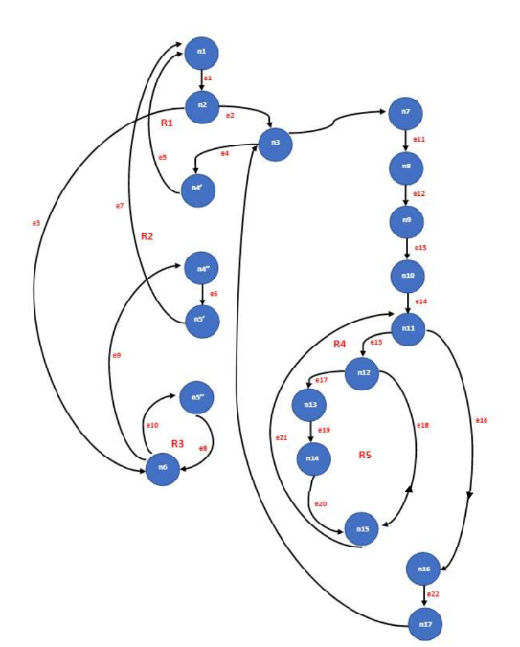

* Calculation of the cyclomatic complexity of the above algorithm

closed regions = 5

VLI (G) = (22 – 19) + (2+1)

VLI (G) = (3) + (3)

VLI (G) = 6

VLI (G) = number of closed regions + 1

VLI (G) = 5 + 1

VLI (G) = **6**

**References**

Marsic, I. (2012). *Software engineering.* Rutgers Unversity. [**http://www.ece.rutgers.edu/~marsic/books/SE/book-SE_marsic.pdf**](http://www.ece.rutgers.edu/~marsic/books/SE/book-SE_marsic.pdf).